Tides, Moons and Surf Fishing
By, Bill Varney Jr.

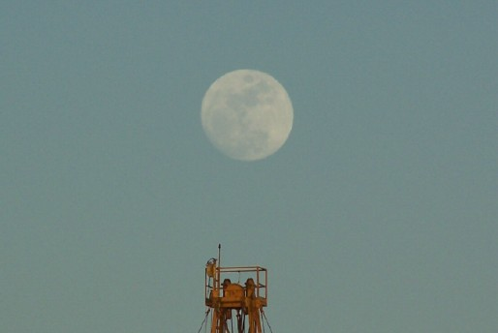

Have you ever wondered what might be the best tide or moon phase to surf fish? There’s no doubt both of these occurrences have a big effect on surf fishing.

Tidal movement and moon phase are two of the least understood natural phenomenon yet combined they have one of the most pronounced influences on surf fishing. Higher tides expose more food and provide more underwater structure than low tides. Full moon phases give fish more light to feed and can dramatically change the hours of day found to be the most productive.

What Causes Tides
It is important to understand the relationship of tidal fluctuations and moon phases because of their pronounced affect on the quality of fishing.

The levels of the ocean fluctuate daily as the Sun, Moon and Earth interact. The Earth’s inward pull, known as gravity, affects the Moon by holding it in orbit. The Moon’s gravity, at the same time, is also pulling at the Earth. The gravitational attraction of the Moon causes the oceans to bulge out in the direction toward the Moon, (sub-lunar point). The Earth itself is also being pulled toward the Moon (and away from the water on the far side). This creates another bulge on the opposite side of the Earth away from the Moon, (antipodal point). The combined gravitational forces as the Moon orbits around the Earth and as both, together, revolve around the Sun, causes the world's oceans to rise and fall. With the Earth rotating on its axis while all this is happening two tidal cycles occur each day, (in most places). Variations in coastline topography may have significant affects on localized tides.

What Tide Is Best For Surf Fishing
The optimal tide would allow for roughly a six-foot tidal swing. For example, a morning low tide of 0.2 feet and an afternoon high tide of 6.2 feet would allow for this six-foot swing. Tidal movements greater than this create strong upcoming and receding water movement. These excessive movements make it difficult for fish to see and catch bait. Tidal movement less than four feet, and especially during diurnal or neap (small swing) tides, cause the opposite condition: very little water movement and much less rotation of bait through the strike zone.

When it comes to what is the best tide for surf fishing there are several answers. For beaches that have been dredged ( Hermosa, Manhattan, Redondo, Seal Beach, Huntington Beach, etc.) generally, two hours before to two hours after high tide seems to be the best time. On these beaches there is very little structure so fish move into the inner trough area at high tide to feed and hide from predators.

On beaches which are still in their natural state (Malibu to Pt. Mugu, Palos Verdes, San Clemente and many beaches of San Diego County) you will find that both low and high tide are good times to fish. The topography for these areas has not been changed (other than by waves) for centuries so they hold structure at both tides that attract fish. My suggestion here is to fish both low and high tides and see which is most productive.

Then we come to fish and the tides they like for eating. I like to fish for corbina and spotfin on the incoming tide because each successive wave moves them farther up the beach and over the previously dry sand crab beds. For surf perch I like fishing the high tide going to low tide as it seems the receding waves and water help to pull my bait into the offshore trough where the fish are.

For halibut fishing forget everything you know about other fish. They are lazy by nature and tend to feed mainly at peak high and peak low tide when there is very little water movement. Halibut generally don’t school like other fish and lay buried in sand or perched upon a rock waiting for the right time to strike.

Because of their flat shape they don’t do well in strong currents so they tend to remain inactive during tide changes. That why you will find that some of your best halibut fishing in the surf is from one hour before peak high or low tide when the water is calm during the slack tide period.

Also, when fishing areas that are rocky (or adjacent to rock, river mouths and harbors) many of the most favorable areas may not be accessible until the tide drops—So try your favorite spots at both high and low tide to find when and where the best places to fish are. You may be surprised to find the best structure can only be reached at the lowest tide.
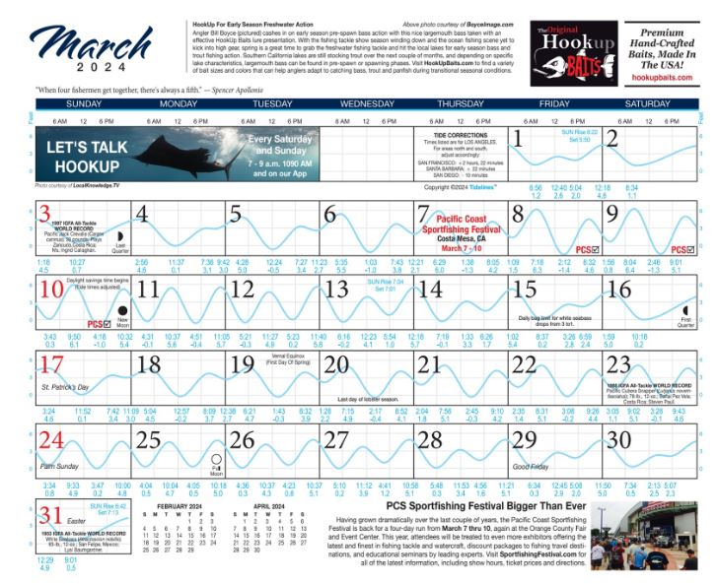

How To Read Tide Charts
Tide charts can be found at your local tackle store, surf shop or on the Internet. They come in small pocket sized books or in the form of a graphic calendar. I prefer tides presented in graph form as seen in the following illustrations. This format makes it very easy to visualize the changes in tidal movement and thus plan your trip accordingly.

Below are graphic calendar illustrations of tidal movement. One of the first things you’ll notice using a graph is that the best fishing tides occur roughly every two weeks.

Semi-diurnal tides (The Best Fishing Tide)
Large water movement
These tides are generally the best time to fish because of the large swings between low and high tide periods. Larger tidal swings mean more bait and current which are both attractive to surf fish.
Diurnal (neap) tides (The Least Desirable Tide)
Very little water movement
Generally, the largest tidal changes are during the full and new moon phase. This will cause the largest movement of water and provide both opportunity and challenge to the fisherman. Some of the best fishing and bait catching conditions occur during these moon phases. Conversely, diurnal or neap tides are the best tides for fishing halibut because of the lack of current and water movement help flat fish hunt their prey.

Fishing big tidal changes is great for corbina, spotfin, yellowfin and perch. While small tidal changes and periods around the “slack” tide are best for targeting halibut.

The Moon’s Affect On Surf Fishing
There is much speculation about how the Moon affects fishing. Many long-range fishermen swear by the notion that a full moon means a great bluefin tuna bite. But this is mostly a myth with very little scientific backing.

One thing we do know about the moon phase is that during a full moon fish will feed at night because they are able to see and track bait. During new moon periods (when the moon is dark) fish feed most actively in the very early morning and evening when the light is bright enough to see their forage but low enough to hide them as predator.

During a full moon period the biological clock for fish is pushed back while they digest what they have caught and eaten during last night’s full moon. With this in mind, look for fish to feed later in the day. Whereas, during a new moon period fish prefer to bite both early in the morning and in the evening.

Both tide and moon phases have a dramatic effect on surf fishing. Take some time planning out your tide and moon phases before your go fishing. I guarantee that what a bit of planning and a little luck you are sure to catch more fish at the beach.

